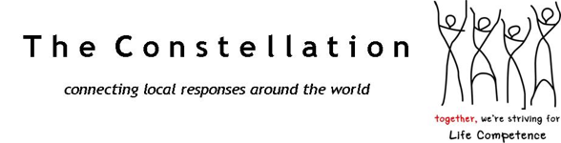

CONCEPT NOTE

Mobilizing local strengths to xxx

The objective
The Constellation (international NGO, Belgium based) offers to work with … to train facilitation teams in xxx(Country, region…) whose objective is to develop Informed, competent and resilient communities in xxx (Country, region…) who mobilise their own strengths to make measurable and verifiable progress in the response to XXX (issue).

Context (of the issue in the area)

The actual situation in XXX regarding XXX invite us to think through an other way to face this issue.
XXX (Issue) is the common dream in this offer, and to realise this dream we need more than, XXX we need to face the issue in giving to communities the opportunity to act and respond localy with they own ressources, strenghts and dream, to this issue.
Indeed, (THERE ADD sentences on the situation in the area and the progress we can observe regarding the law or any local or national program to face this issue).

The Constellation offer to go further in those efforts to realise the dream of XXX (Country, region…) communities, government and local organisations. The experiences show that when communities act from their own strength to address the issue of XXX, long lasting progress can be recorded. Communities has their own strengths but they may not know it or may need stimulation to act from their strengths.

The Constellation
Since 2005, the Constellation has grown as a global movement of communities and practitioners from over 96 countries. The Constellation formally worked with more than 60 organizations in more than 40 countries including governments, UN agencies, civil society and the private sector.
Members of the Constellation share a common inspiration: a belief in the capacity of communities to envision, assess and take action, starting from their strengths. We develop and nurture the capacity to facilitate communal discussion, reflection, learning and action.

The experience of the Constellation shows that two things are required for a community to take local action: ownership of the issue and the response and realization and use of own strengths.

During program implementation, the role of The Constellation is to offer a blend of on-site and distance support, through a dedicated team of coaches. These coaches have experience facilitating local responses in different settings, have coached similar processes in other countries and will offer valuable diversity of life and work experience. For events, coaching teams will be carefully selected so that their skills and (cultural) experience complement one another and are well suited to the needs of the local partners.
The Constellation has a network of thousands of facilitators around the world and more than 60 coaches based in more than 25 countries in 5 continents. These coaches are able to transfer the approach to new facilitators and accompany its implementation in the field.

To set up CLCP facilitation teams in Sudan we would bring together experienced coaches from countries as RD-Congo, Burundi, Guyana, India and Indonesia where good practices on the reduction of gender based violence are registered. A coaches team would help identify existing good practices in Sudan, share own experiences, train new facilitators in the approach and accompany them in the application to the specific Sudanese context.

The approach
The Constellation proposes a process (the Community Life Competence Process) or in short ‘CLCP’ to facilitate action towards Life Competence. The process consists of a number of steps and tools that can be facilitated, together with a strength-based way of working.

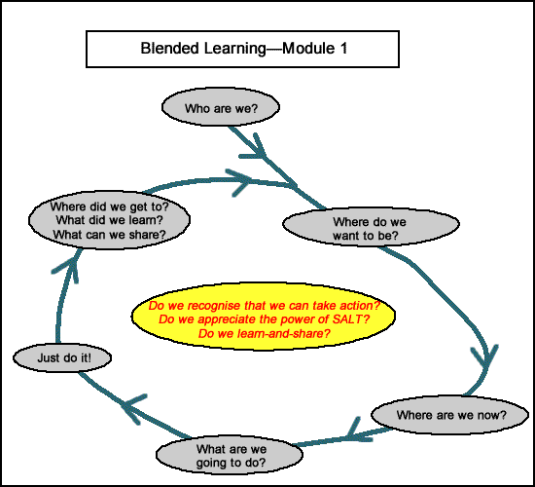
The main objective of the process is to strengthen local competence and capacity to take action from strengths. The ‘SALT’ approach (Stimulate, Appreciate, Learn, Transfer) reveals the capacity of communities to build a vision for the future, to assess, to act, to adapt and to learn.

At each step of the process, a facilitation team supports the community with an appreciative way of working and a set of tools.
Measurement of progress happens through a combination of outside ‘meta-level indicators’ suggested by partners and community-generated indicators to measure local progress.
Based on their own dream and their competences, the community develop their action plan and this will be the based for their self-assessment to measure the progress on XXX.

The Constellation offers an holistic approach to facilitate a behavior change by a change of outlook. This change is multiple. Is the one of the XXX (communities we work with on this issue) as well as the social workers or the political representation. The Constellation experience shows that when all development actors accompany the process extends beyond the target group.

We can observe 3 levels of learning:
- The community ( XX, XX and all members of the community) learn about their own strength and capacity to realise their dream and based on their own resources they make remarkable progress on the issue of XXX;
- The organization, local association or social worker realise that the community and the XXX (communities we work with) are the actors of they own development and they have the key to discuss about XXX and develop local respons to face this issue;
- The political instances and governement learn about local responses and adapt they policy.

Applications of CLCP to XXX (issue)

Here add our experience in applying CLCP to this issue

